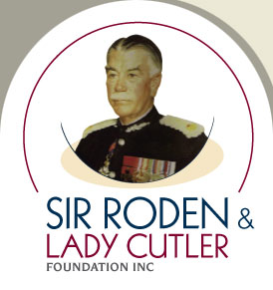

Bequest (Gift) Pledge Form

If you have decided to make a gift to the Sir Roden & Lady Cutler Foundation in your Will it would be very helpful if you could let us know by completing this form. This does not commit you to a particular course of action or limit your freedom to change your Will in the future. It is simply a statement of your present intentions.

I confirm that I have included a gift to the Sir Roden & Lady Cutler Foundation in my Will and I would like my bequest to support:

Unrestricted Fund (for use at the organization’s discretion)
The Foundations “Pick Me Up” Service
Other (please specify) _________________________________________________________________

The Sir Roden & Lady Cutler Foundation recommends you make your wishes known to your beneficiaries and/or the executor of your estate.

I have discussed my wishes with my family and friends and/or the executor of my Will; or
I do not wish to discuss my bequest with my beneficiaries or executor but are committed to my donation.

Please indicate below (in complete confidence) the approximate value of your gift, or the proportion of your estate, if you are able to do so:
_____________________________________________________________________________________________

Name _____________________________________________________________________________________
Leaving Amount (if applicable) $____________House % (if applicable) ________________
Address ___________________________________________________________________________________
Telephone ___________________________________ Mobile ____________________________________
Email ______________________________________________________________________________________

Please contact me to discuss a possible bequest (gift).
I wish to make a bequest to the Sir Roden & Lady Cutler Foundation and would prefer not to have my name publicly disclosed.
I do not wish to make a bequest to The Sir Roden & Lady Cutler Foundation or be contacted regarding this in the future.

Please return this form to:
Mr. Vincent Del Zio Chief Executive Officer
Sir Roden & Lady Cutler Foundation
PO Box 842
Concord NSW 2137

E: vdelzio@sirroden.org.au
T: (02) 8765 8661

